**VOICE BASED APPLICATION FOR VISUALLY IMAPIRED**



**A PROJECT REPORT**

***Submitted by***

**DEEPTHI.R (1BM16CS030)**

**HARINI.B.M (1BM16CS033)**

**KRITHIKA.G.M (1BM16CS043)**

**ZAINA AHAD (1BM16CS149)**

***in partial fulfillment for the award of the degree of***

**BACHELOR OF ENGINEERING**

***in***

**COMPUTER SCIENCE AND ENGINEERING**

***Under the Guidance of***

|  |  |
| --- | --- |
| **PRADEEP SADANAND**  **Assistant Professor, BMSCE** |  |
|  |  |



**B. M. S. COLLEGE OF ENGINEERING**

**(Autonomous Institution under VTU)**

**BENGALURU-560019**

**MAY 2020**

**DEPARTMENT OF COMPUTER SCIENCE AND ENGINEERING**

**CERTIFICATE**

Certified that the project entitled VOICE BASED APPLICATION FOR VISUALLY IMPAIRED is a bonafide work carried out by DEEPTHI.R (1BM16CS030), HARINI.B.M (1BM16CS033), KRITHIKA.G.M (1BM16CS043), ZAINA AHAD (1BM16CS149) in partial fulfillment for the award of Bachelor of Engineering in Computer Science and Engineering of the Visvesvaraya Technological University, Belagavi during the academic year 2019-20. The project report has been approved as it satisfies the academic requirements in respect of project work prescribed for the said degree.

|  |  |
| --- | --- |
| **Pradeep Sadanand** | **Dr. Umadevi V** |
| Assistant Professor | Associate Professor and Head |
| Dept of CSE, B.M.S. College of Engineering | Dept of CSE, B.M.S. College of Engineering |

**Guide Head of Department**

**Principal**

**Dr. B. V. Ravishankar**

B.M.S. College of Engineering

External Viva

Name of the Examiners Signature with Date

1.

2.

**TABLE OF CONTENTS**

|  |  |  |
| --- | --- | --- |
| **TITLE** | | **PAGE NO.** |
| **ABSTRACT** | | **i** |
| **Declaration by the student batch and guide** | | **ii** |
| **Acknowledgements** | | **iii** |
| **List of Figures** | | **iv** |
| **List of Symbols / Abbrevations** | | **v** |
|  | | | | |
| **CHAPTER NO.** | **TITLE** | | | **PAGE NO.** |
| 1. | **Introduction** | | | 1-3 |
| 1.1 | Overview | | | 1 |
| 1.2 | Motivation | | | 1 |
| 1.3 | Objective | | | 2 |
| 1.4 | Scope | | | 2 |
| 1.5 | Existing System | | | 2 |
| 1.6 | Proposed System | | | 3 |
| 2 | **Literature Survey** | | | 4-7 |
| 3 | **Software and Hardware Requirement Specification** | | | 8-9 |
| 3.1 | Functional Requirements | | | 8 |
| 3.2 | Non-functional Requirements | | | 8 |
| 3.3 | Hardware Requirements | | | 9 |
| 3.4 | Software Requirements | | | 9 |
| 3.5 | Cost Estimation | | | 9 |
| 4 | **Design** | | | 10-17 |
| 4.1 | **High Level Design** | | | 10 |
| 4.1.1 | System Architecture | | | 10 |
| 4.2 | **Detailed Design** | | | 11-16 |
| 4.2.2 | Use-case Diagram | | | 13 |
| 4.2.3 | Class Diagram | | | 14 |
| 4.2.4 | Data Flow Diagram | | | 17 |
| 5 | **Implementation** | | | 17-22 |
| 5.1 | Overview of Technologies Used | | | 18 |
| 5.2 | Implementation details of modules | | | 19-21 |
| 5.3 | Difficulties encountered and Strategies used to tackle | | | 22 |
| 6 | **Testing and Experimental Analysis and Results** | | | 23-24 |
| 6.1 | Evaluation Metric | | | 23-24 |
| 6.2 | Performance Analysis | | | 23-24 |
| 6.3 | Test Case Validations | | | 25-26 |
| 6.3.1 | Test cases for android application | | | 25 |
| 6.3.2 | Test cases or web application | | | 26 |
| 6.3.3 | Test cases for encryption | | | 26 |
| 7 | **Conclusion And Future Enhancements** | | | 27 |
| 7.1 | Conclusion | | | 27 |
| 7.2 | Future Enhancements | | | 27 |
| REFERENCES | | | | 28 |
| APPENDIX A: Results Snap shots | | | | 29-31 |
| APPENDIX B : Plagiarism Report | | | | 32 |
| APPENDIX C: Details of list of publications related to this project | | | | 33 |
| APENDIX F: POs Mapped | | | | 34-37 |

**ABSTRACT**

People who are visually impaired, would like to share data, information, records. One way to accomplish this is by using voice recognition software to train the device to recognize text and commands which are being issued. A mobile application is used to get user credentials and a backend database stores and verifies this data. The translation is accomplished using Google API’s which are based on AI and ML.

This project has the following phases, the first phase is to develop an easy user interface which enables the authentication of the supplicant through voice-based commands. The next phase consists of creating a database which stores all the credentials of the user and his/her related information. The final phase consists of the user being able to perform various activities such as composing e-mails, setting remainders, battery percentage and password protection.

**DECLARATION**

We, hereby declare that the dissertation work entitled VOICE BASED APPLICATION FOR VISUALLY IMPAIRED is a bonafide work and has been carried out by us under the guidance of Pradeep Sadanand Assistant Professor, Department of Computer Science and Engineering, B.M.S. College of Engineering, Bangalore, in partial fulfillment of the requirements of the degree of Bachelor of Engineering in Computer Science and Engineering of Visvesvaraya Technological University, Belagavi.

I further declare that, to the best of our knowledge and belief, this project has not been submitted either in part or in full to any other university for the award of any degree.

Candidate details:

|  |  |  |  |
| --- | --- | --- | --- |
| SL. NO. | Student Name | USN | Student’s Signature |
| 1 | DEEPTHI.R | 1BM16CS030 |  |
| 2 | HARINI.B.M | 1BM16CS033 |  |
| 3 | KRITHIKA.G.M | 1BM16CS043 |  |
| 4 | ZAINA AHAD | 1BM16CS149 |  |

Place: Bangalore

Date: 01-07-2020

Certified that these candidates are students of Computer Science and Engineering Department of B.M.S. College of Engineering. They have carried out the project work of titled “VOICE BASED APPLICATION FOR VISUALLY IMPAIRED” as final year (7 & 8 Semester) dissertation project. It is in partial fulfillment for completing the requirement for the award of B.E. by VTU. The works is original and duly certify the same.

|  |  |  |  |
| --- | --- | --- | --- |
|  | Guide Name  PRADEEP SADANAND |  | Signature |

Date

01-07-2020

**Acknowledgements**

We would like to thank professor Pradeep Sadanand for his excellent guidance and constant support towards helping us to achieve the outcomes of this project and stirring us in the right direction. We are thankful to the department of Computer Science for guiding us towards the completion of the project and giving us a platform to showcase our work. We are also thankful to BMS College of Engineering for all the facilities and resources provided to us for the completion of this project.

**List of Figures**

|  |  |  |
| --- | --- | --- |
| **Figure. No.** | **Figure Caption** | **Page No.** |
| 2.1 | AES Algorithm | 5 |
| 4.1.1 | High Level System Architecture | 10 |
| 4.1.2 | Admin Use Case Diagram | 10 |
| 4.2.1 | Detailed System Architecture | 11 |
| 4.2.2 | Android User Use Case Diagram | 12 |
| 4.2.3.1 | Class Diagram for Admin | 13 |
| 4.2.3.2 | Class Diagram for Android User | 13 |
| 4.2.4.1 | Sequence diagram for Admin functionalities | 14 |
| 4.2.4.2 | Sequence Diagram For Android User Functionalities | 15 |
| 4.2.5.1 | Data Flow Diagram for Android User Session | 16 |
| 4.2.5.2 | Data Flow Diagram For Password Recovery | 16 |

**List of Symbols / Abbrevations**

|  |  |  |
| --- | --- | --- |
| **Sl. No.** | **Symbols /Abbrevations** | **Description** |
| 1. | AES | Advanced Encryption Standard |
| 2. | DSA | Digital Signature Algorithm |
| 3. | DES | Data Encryption Standard |
| 4. | API | Application Programming Interface |
| 5. | JDK | Java Development Kit |
| 6. | ADT | Android Development Tool |
| 7. | SDK | Software Development Kit |

Chapter 1

Introduction

* 1. Overview

There have been many efforts but even now, it isn’t easy for visually challenged people to work easily on computers or smart phones. This has led us to the concept of voice recognition techniques. This concept of creating a specialized voice application helps visually impaired people to work better with mobile devices and computers.

This system proposes a voicemail architecture which can be used by a visually impaired person in order to send mails in an easy and in a more efficient manner. The proposed application has online password manager with voice mail system. In this application all the user passwords are encrypted and stored on a web server. Users can also retrieve their passwords through voice commands using the mobile application. The application enables users to send emails, recover passwords, set reminders and get to know the battery percentage with the help of voice commands, thus making it easy and useful for visually impaired users.

* 1. Motivation

Nearly 50 million people in our country alone, including about 1.6 million children, are either blind or visually impaired. With the advancements of recent technologies, mobile phones have become a very important part of modern life. Most of us who need to make a call or send a message at any instant can do so from any location. This simple task of sending mails often becomes a stressful task for the visually impaired. Hence to overcome this basic problem, the proposed android application has been developed as a secure password manager with voice mail system.

* 1. Objective

The following was the goal and objective that was prepared to make the application commercially available on a Play store. The main focus of the system is to develop a mobile based voice e-mail system with Secure Password Manager for visually impaired people enabling them to send emails and recover passwords.

* 1. Scope

The purpose of the application is to perform the following major functionalities:-

* Help the visually impaired to send mails easily.
* Help maintain a master password which will enable logging into various platforms
* Set remainders and check the battery percentage through voice commands.
  1. Existing System

Among the early trials, an input in the form of voice had been adopted for the visually challenged people. IBM’s Application has a very easy and user-friendly interface which is used to transform text to speech. However, the disadvantage of this system was the complexity involved in developing the interface. Considering an Indian scenario, Shruti-Drishti and a Web-Application for visually impaired are the two web applications that are used by visually challenged person to connect to the internet and hence the capability to send e-mails.

* 1. Proposed System

The visually impaired people face challenges daily in communicating with the ever growing and fast changing world. These people are largely dependent on their sighted colleagues for various needs either to make a phone call or to perform other tasks. This system is based on speech to text conversion application for mobile devices which allows an easy way to send an E-mail. Also this system comes with Secure Password Management system which store the password in web server in encrypted form and when the user need the password, user can retrieve the password through voice command. This system comes with low battery alert and Remainder management.

Advantage in Proposed System

* Intelligence in achieving hands free speech
* More security for passwords
* Encryption is used to secure user credentials.
* The users enjoy a hassle free usage of the application.

Chapter 2

Literature Survey

2.1 AES Algorithm

There are broadly two types of encryption techniques, they are Symmetric and Asymmetric encryptions. In Symmetric Encryption a single key is required in order to encrypt and decrypt data i.e. both the users must have knowledge about the specific key in order to access data. Examples of this type include Blowfish, AES, AES-128, AES-192, AES-256 etc. Asymmetrical encryption which is a relatively new method, compared to symmetric encryption.

Asymmetric encryption uses two keys to encrypt a plain text. Secret keys are exchanged over the Internet. Anyone who has access to the secret key can decipher the message and hence asymmetric encryption makes use of related keys for more security.

A public key is available to allow the user a message. The second private key is hidden so that only the user will know and decrypt the message. Some examples of this type of an algorithm includes DSA, Elliptic curve techniques etc.

In this system a Symmetric encryption algorithm known as the AES Algorithm is made use of. It is very popular and widely used these days. It is found at least six time faster than triple DES.

A replacement for DES was needed as its key size was too small and also because of the fear of an exhaustive key search attack. AES is also being used here as it provides full specification and design details.

Implementation of AES algorithm can be done easily using C or JAVA. It supports 3 key lengths of 128 bits,192 bits and 256 bits. It performs all of its transformations in the form of bits and not bytes.

AES is impossible to hack without having adequate knowledge about the input key. The flexibility with key length is another advantage of the AES algorithm. It is a strong cipher and provides high security. The only disadvantage of this type of encryption algorithm would be the simplicity of the key which is used which might lead to an attack sometime

Fig.2.1 AES Algorithm

2.2 Google Speech to Text API’s

These google API’s are a product of google and is based on AI and ML. This is a cloud based speech to text converter and converts audio to text with the help of applying strong and powerful neural network models integrated within an easy to use API.

This API can recognize up to 120 different kinds of languages in order to support users globally. It can process audio in real time and recorded audio by using Google’s machine learning technology.

These API’s enable users to speak commands and has the capability of returning appropriate data. Cloud speech to text can analyze both long form and short form of data and can convert audio into text immediately.

It can also accurately transcribe proper nouns and can appropriately format language. It is a very robust API as it can handle audio from noisy environments easily. It automatically and appropriately uses punctuations in sentences.

This API has 3 types of requests based on audio content, they are Synchronous, Asynchronous and Streaming Requests. In synchronous requests the audio should be 1 minute long and the user need not upload the data to the cloud.

In asynchronous requests the audio should be 480 minutes long and the user needs to upload the data to the cloud. It is suitable for streaming data where the user is talking to microphone directly and needs to get it transcribed. In this project the API’s are implemented and the user will speak the login commands or credentials which will be converted to text and emails can be sent to the users recipients.

2.3 Literature Studies

Jin-Hee Lee etal. [1] has proposed a system where in a visually impaired person can be guided to reach home in a safe and secure manner. For implementing this idea Zigbee modules were used to understand the signals intensities. Ultrasonic sensors were used to gauge the distance from various objects in the path of the traveller. Varit Prudtipongpun etal. [2] has proposed a system for the visually impaired to navigate in an indoor space. This is achieved by uploading a floor plan on Google maps which enabled a safe and secure navigation.

Zewen Lee etal. [3] has proposed a system to capture the insight scene details using the camera of a mobile device. They have implemented a stabilization technique based on the motion and this helps overcome the jitter issues. R.Kasthuri etal.[4] has proposed a voice based application used by the visually impaired to set remainders and listen to music in an easy manner. They have implemented the above using Selendroid which helps in the communication between the mobile devices and the servers.

Carmel Mary Belinda M.J. etal [5] has proposed a system to enable the visually impaired to exchange messages without the need of typing it. Voice Activation Detection API is used to convert speech to text. Answer Activation Detection API is used to give the response back to the user. Jayachandran.K etal [6] has proposed a system to enable the blind to communicate easily by creating an instant messenger which will enable communication with any other user connected over the network.

Jing-zhong wang etal[7] proposed a system to enable imagine projection method to calculate image boundary and also uses speech to prompt the directions. Piotr Kardyś etal [8] proposed a system wherein the speech is passed through the GSM network. The program developed also checks if the received words are making up any one of the available commands.

Chapter 3

Requirement Analysis and Specification

* 1. Functional requirements
* This system is an online application which allows users to access their respective accounts and performs the task of sending e-mails and securing passwords.
* On the login page the users are prompted to speak their details in order to login to their respective accounts.
* If the details are valid the users are authorized to access their mails.
* Once logged in tasks such as setting reminders and battery percentage will be prompted to the user.
* The application is written in Java.
* The application consists of two major login portals:-

1. Admin
2. Users
   1. Non-Functional Requirements

* The system is an online system and requires an internet connection. Thus the speed maybe slow or fast depending on the client server.
* The user must create an account in order to have access.
* Login time should not take more than 15 seconds.
  1. Hardware Requirements
* Hard Disk : 500 GB.
* RAM: 4 GB.
* An Android phone.
* Any desktop / Laptop system with above configuration or higher level.
  1. Software Requirements
* Operating system: Windows 7 / Windows 8
* Java Development Kit (jdk)
* MySQL 5.0
* Tomcat
* ADT bundle
* Eclipse
  1. Cost Estimation
* Laptop- Rs. 85,000
* Android Phone- Rs-50,000

Chapter 4

Design

4.1 High Level Design

4.1.1 System Architecture

Fig.4.1.1 illustrates the high level system architecture of the application. From the figure it can be seen that the web server and the android application are interacting through the wireless application protocol(WAP). The application consists of a web interface used by the admin. This web interface has access to the password database which consists of the password details in an encrypted format. The admin will have the provision of viewing the passwords in the decrypted format. The other part of the application is the android application which enables a user to login and perform various functions such as composing and sending voice enabled emails, checking remainders and getting alerts for the battery percentage.

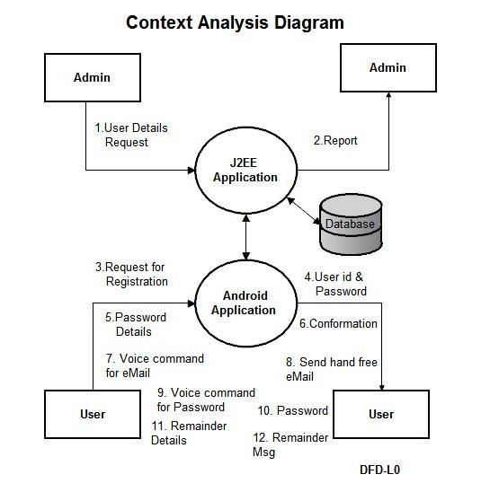

Fig.4.1.1 High Level System Architecture

4.2 Detailed Diagram

4.2.1 Use Case Diagram

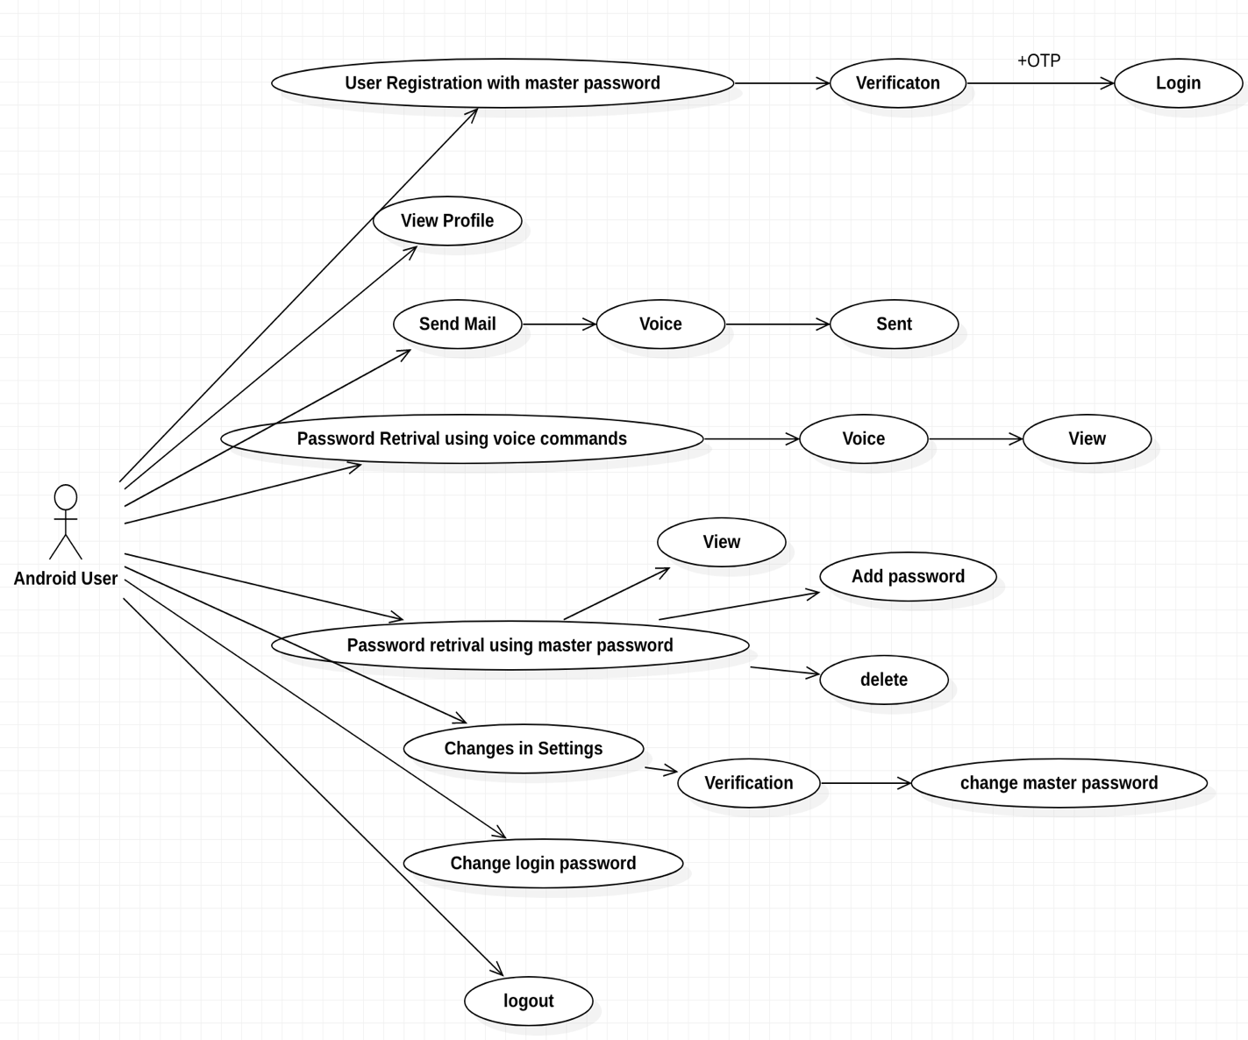

Fig 4.2.2 Android User Use Case Diagram

Figure 4.2.2 describes the use cases if the android application user. The user on successful login will be able to view profile information, send voice enabled e-mails, retrieve passwords using voice commands and master password, change certain settings in the profile and logout.

4.2.2 Class Diagram

Figure 4.2.2.1 and 4.2.2.2 describe the various classes used by the admin and the user.

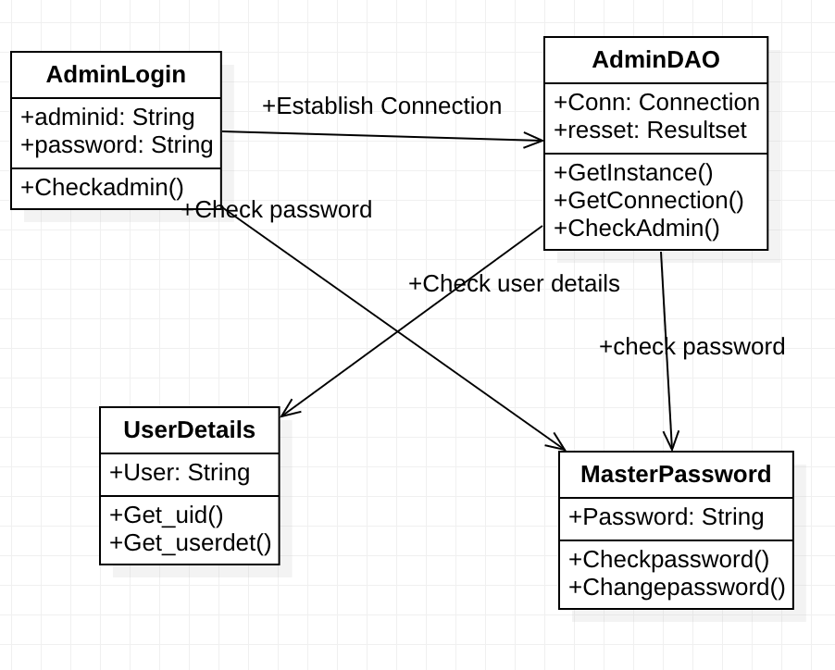

Fig 4.2.2.1 Class Diagram for Admin

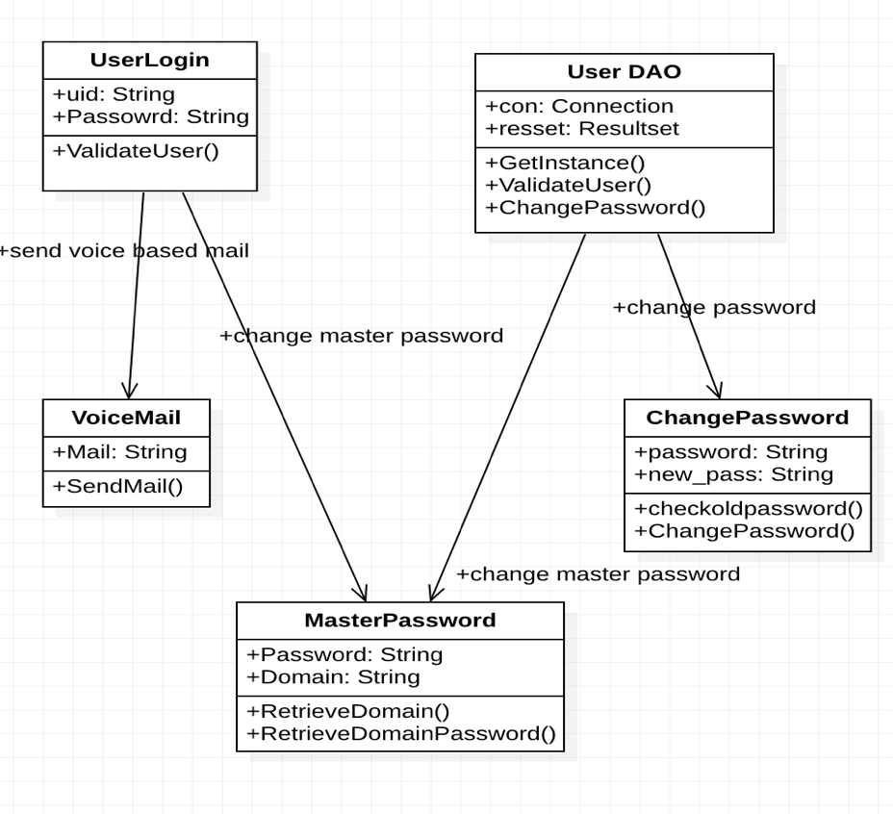

Fig 4.2.2.2 Class Diagram for Android User.

4.2.3 Data Flow Diagram

Figure 4.2.3.1 and 4.2.3.2 describe the flow of events for the android user and for the password recovery mechanism.

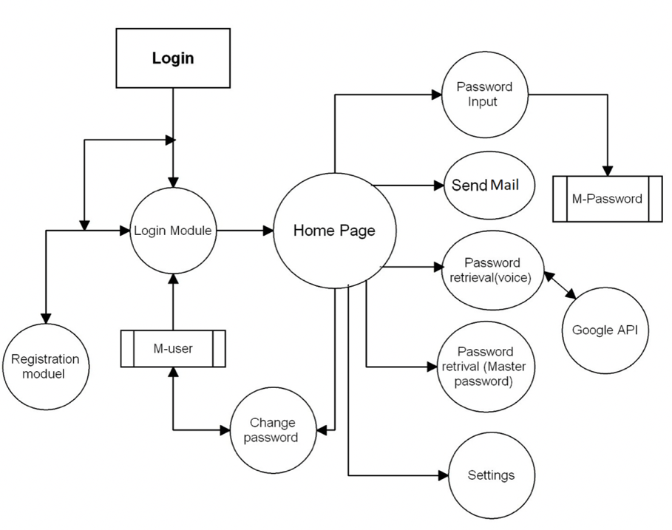

Fig 4.2.3.1 Data Flow Diagram for Android User Session

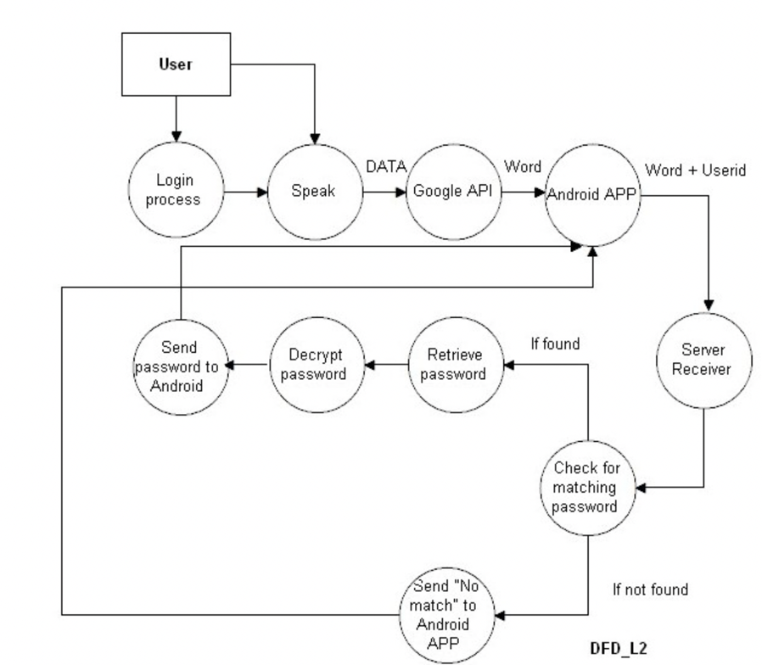

Fig 4.2.3.2 Data Flow Diagram For Password Recovery

Chapter 5

Implementation

5.1 Overview of Technologies Used

5.1.1 Eclipse IDE

Eclipse is an integrated development environment used in computer programming. It consists of a base workspace and plugins for customizing the environment. By visiting the official site of eclipse one can easily download the IDE and use it to develop efficient projects. The pre-requisite for the installation of eclipse IDE is to have a Java Development Kit (JDK) present in the system.

5.1.2 Eclipse ADT Plugin

The ADT plugin for Eclipse adds extensions to the Eclipse IDE. This extension helps to debug Android applications efficiently.

5.1.3 Apache Tomcat

Apache Tomcat is an open-source implementation of the Java Servlet, JavaServer Pages, Java Expression Language and WebSocket technologies. Tomcat provides a "pure Java" HTTP web server environment in which Java code can run.

5.1.4 SQL Yog

SQLyog is a [GUI](https://en.wikipedia.org/wiki/Graphical_user_interface) tool for the [RDBMS](https://en.wikipedia.org/wiki/RDBMS) [MySQL](https://en.wikipedia.org/wiki/MySQL). SQLyog is being used by more than 30,000 customers worldwide and has been downloaded more than 2,000,000 times.

5.1.5 Steps required to install and execute the project:-

1. Install the JDK from the official site.
2. After JDK installs successfully, install the Eclipse IDE.
3. Set up the Android SDK by installing the SDK started package and configure the settings appropriately according to the requirements.
4. After the Android SDK has been set up install the ADT plugin for Eclipse.
5. Create a new project and start with the development of the application.
6. To test the application create an Android Virtual Device (AVD) with the appropriate emulating device and needed configurations.
7. Test the working of the project by launching the virtual device created.
8. Always ensure that the server is started before launching the application or the web interface.

5.2 Implementation Details Of Modules

5.2.1 Module1- Admin login through web interface.

The admin can log in through the web interface developed by providing the admin ID and password and once logged in will be able to view all the user details. Only the admin has the rights to view the master password in the decrypted format so that he/she will be allowed to change the password in certain cases where the user might not be able to access his /her account and a mandatory change of password is needed. The admin also has the provision of changing the admin password also and will be validated once performed and the new password will be recorded in the database.

5.2.2 Module 2- User Registration with master password.

The first time the user wants to login to the application, he/she will be prompted to enter a few details like the username, password, and the master password details. During the registration process an OTP will be sent to the registered mobile number to ensure security. Once the verification of the OTP is completed the user can successfully login to the application and perform the needed functionalities.

5.2.3 Module 3- Sending voice based e-mail

Once the android user successfully logs into the application he/she will be able to compose a mail and send it with voice commands. The user will be prompted by the application to speak out the content of the message and once that is done the mail will be delivered to the respective recipient mentioned by the user again through voice.

5.2.4 Module 4- Battery Percentage Alerts

The android user will also be alerted on the batter percentage of the device and in case it is low will be prompted to put it to change immediately. This module makes it easier for the visually impaired user to be aware of the battery life and hence helps in charging it before the device completely switches off.

5.2.5 Module 5- Setting of Remainders

The android user will be able to send remainders and also be able to get the alert on these remainders at the specified time and date.

5.2.6 Module 6- Password retrieval using master password

After the successful login of the user into the application the user can use the master password to retrieve the password list. On successful authentication of the master password the user will be able to view the password list in the decrypted format. This use of master password has hence benefited to store the password details of other sites in one place for easy access for the visually impaired. If the authentication of the master password is not successful then the password list will not be displayed. The user can also change the master password. If the user wishes to do so then an OTP will be sent to the registered phone number using which the password can be changed. This change of password will be validated and if it is successful it will be stored successfully in the database.

5.2.7 Module 7- Password retrieval using voice

After the successful registration of the user the server verifies the details entered the user will be able to add the password details into the application which will be encrypted and stopped in the database. If the user wishes to retrieve the password details for a particular domain, the user will speak out the domain name. If the domain name is registered in Google API’s, the password details of that respective domain is retrieved and decrypted made available to the user.

5.2.8 Module 8- Change Settings

The user will be able to make important edits to the settings entered during the first time registration. The changes in the settings will require the master password and on successful verification of the master password the settings can be changed and saved.

5.2.9 Module 9- Change the login password

The user can change the login password of the application if necessary and for security reasons. He/she can do so by first getting the master password validated and on successfully validation the user will be able to change the login password to a new one.

5.2.10 Module 10-View Profile

The user will also be given the provision to view the profile details . In case any changes have to be made to the profile values the master password can be used as the bridge to validate the identity of the user and on successful validation the user can make edits and view the new profile details.

5.3 Difficulties encountered and Strategies used to tackle

The following difficulties were faced during the development of this project:-

* Failure in the functioning of the emulator.
* Repositioning of the application element on different devices.
* Configuring the ADT within eclipse.

Chapter 6

Testing and Experimental Analysis and Results

6.1 Evaluation Metric

Various tools were used for evaluating the developed application such as Firebase TestLab and Clashlytics.

The metrics supported by them are:-

* App Crashes
* Speed
* Latency
* CPU utilization
* Memory

6.2 Performance Analysis

The Firebase TestLab provides an easy environment for testing the developed application to see whether the application is functioning correctly or not. It displays the sequence of events that occur and also displays the CPU utilization and memory usage. It allows users to virtually select any device on which the application can run to understand the behavior of the application in real life scenarios. This will help the developer to improve the application before releasing the actual fully functioning version to the market. Logs are also provided to check for the places of errors. The user is also given the option to skip some fields if necessary which he/she might not find it necessary to test.

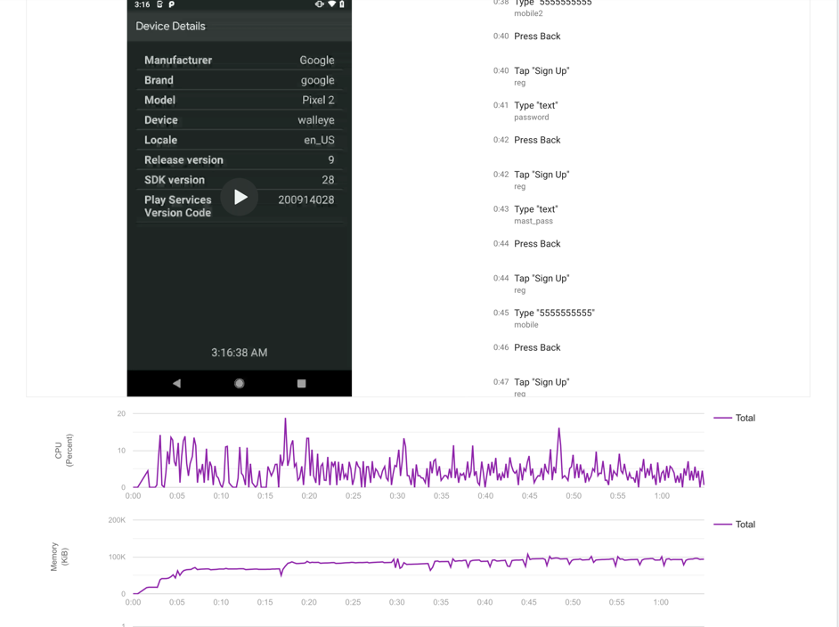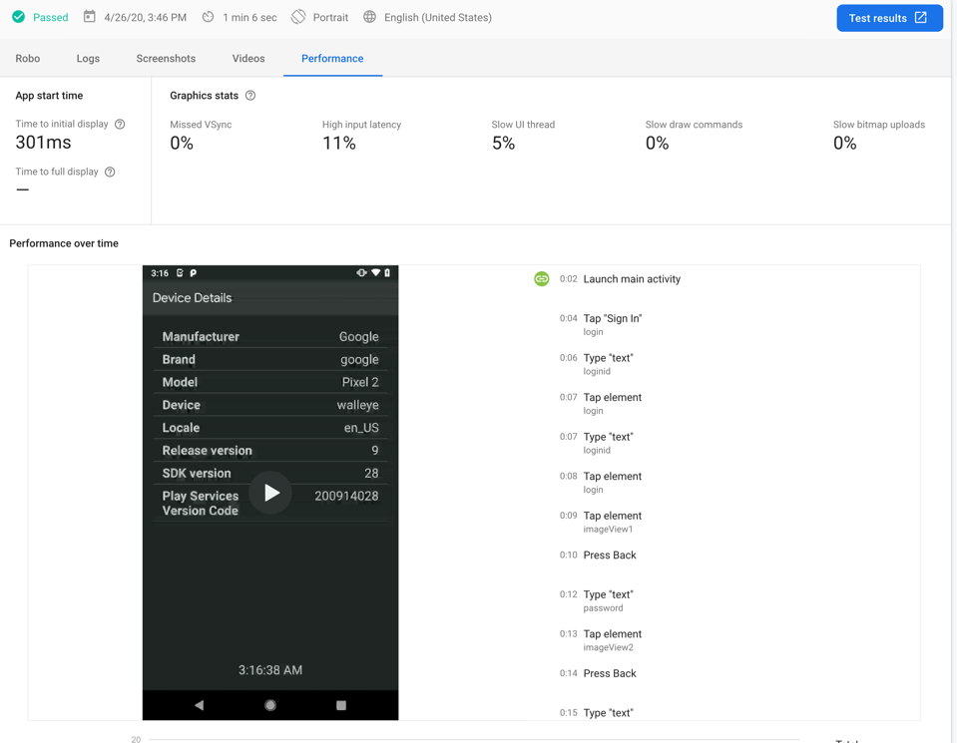The following are the snapshots of the results of the test performed

6.3 Test Case Validations

6.3.1 Test Cases for Android application

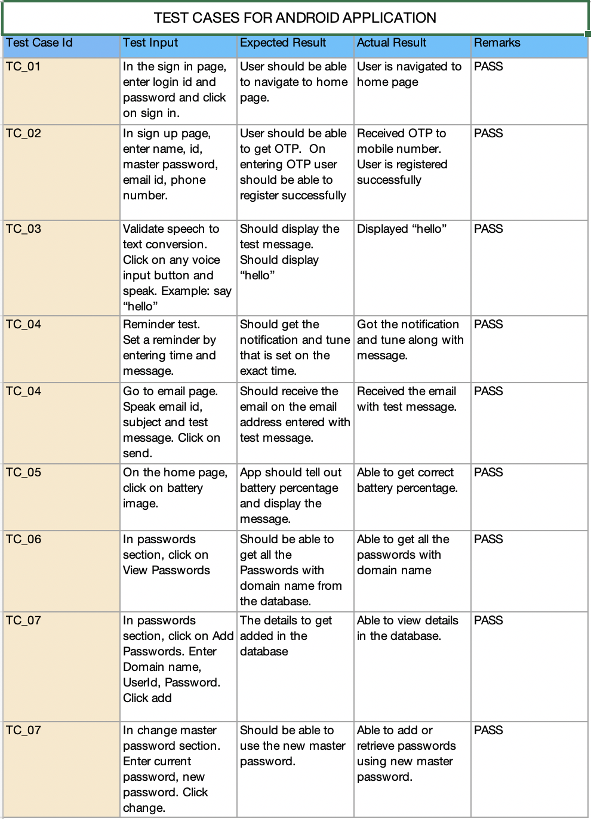

6.3.2 Test cases for web application

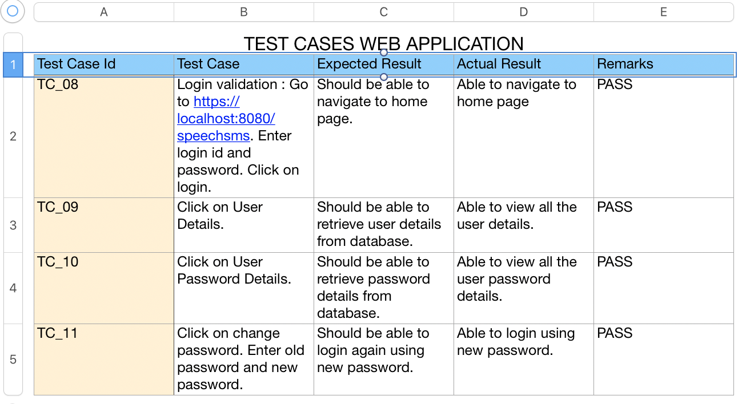

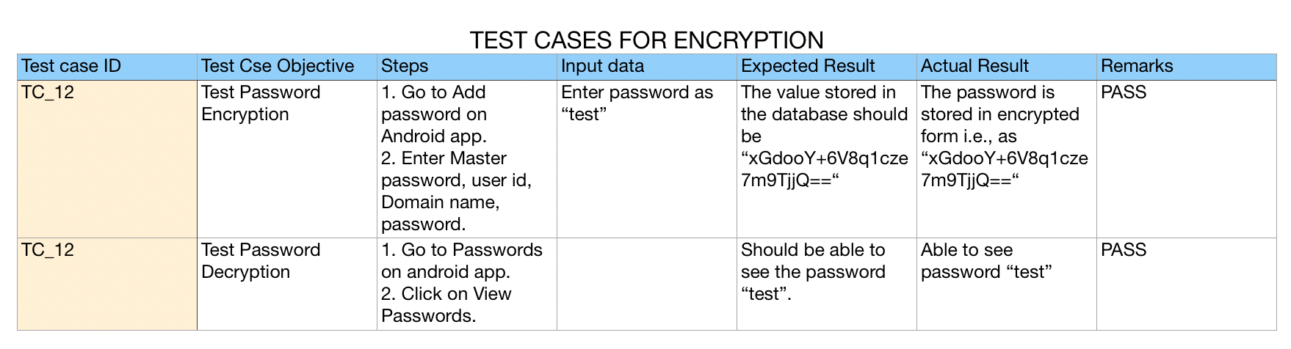6.3.3 Test cases for encryption

Chapter 7

Conclusion and Future Enhancements

* 1. Conclusion

The project aims at the betterment of society by making use of the latest technologies available to mankind and helping the needy in the best way possible. By taking up the task of developing more projects under this category it will motivate technologists to build more applications for the visually impaired. With the help of a smartphone the blind can virtually “see” and become more independent

* 1. Future Enhancements

One possible improvement is that the system can be made more standalone and portable and made more compatible for different operating systems. The future work of this application can be used to detect different types of languages with better accuracy of the words being pronounced by the user. The future work can also include the use of audio.

References

[1] Jin-hee Lee, aSang-Chul Lee, aKyeongyul Kim, and aByeong-Seok Shin, “Smarta Backpacka for Visually Impaired Person”, International Conference on ICT for Smart Society-IEEE, June 2013.

[2] Varit Prudtipongpun, Thorntita Rattanapongsen, Wirawan Buakeaw and Mingmanas Sivaraksa, “Indoor Navigation System for Vision-impaired Individual”, IEEE-International Conference on Signal-Image Technology & Internet-Based Systems (SITIS), 2015.

[3] Zewen Li, Gang Luo and Shrinivas Pundlik, “Stabilization of Magnified Videos on a Mobile Device for Visually Impaired”, IEEE Conference on Computer Vision and Pattern Recognition Workshops, 2013.

[4] R.Kasthuri, B.Nivetha, S.Shabana, V.Veluchamy, S.Shivakumar 2017 Third International Conference on Science Technology Engineering & Management (ICONSTEM), “Smart device for visually impaired people” .

[5]Carmel Mary Belinda M.J. , Rupavathy.N , Mahalakshmi N R, International Journal of Engineering and Technology(2016), “A voice based text mail system for visually impaired”.

[6] Jayachandran .K, Anbumani .P, International Journal of Advance Research, Ideas and Innovations in Technology (2017), “Voice Based Email for Blind People”.

[7] Jing-zhong wang, xiao-hui guo, ke xiao, 2016 IEEE, “research and implementation of blind reader system based on android platform.”

[8] Piotr Kardyś, Adam Dąbrowski , Marcin Iwanowski, Damian Huderek 2016 IEEE, “A new Android application for blind and visually impaired people”.

APPENDIX A: Results Snap shots

Admin Login Snapshots:-

Login Page

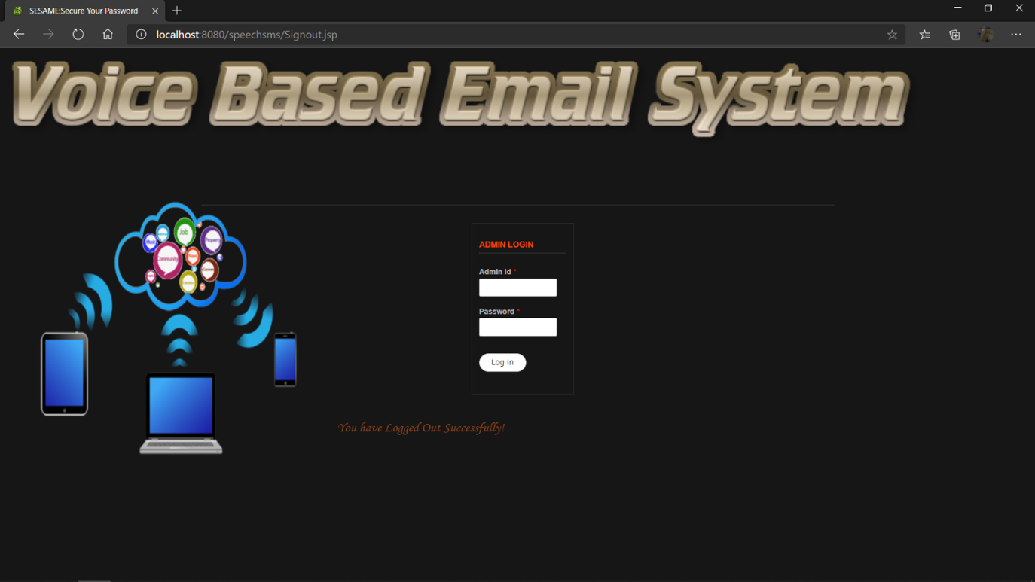

User Details Page

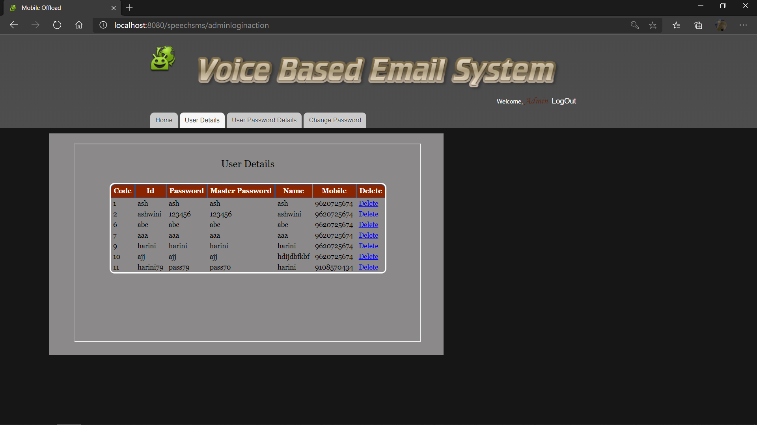

Change Password Page

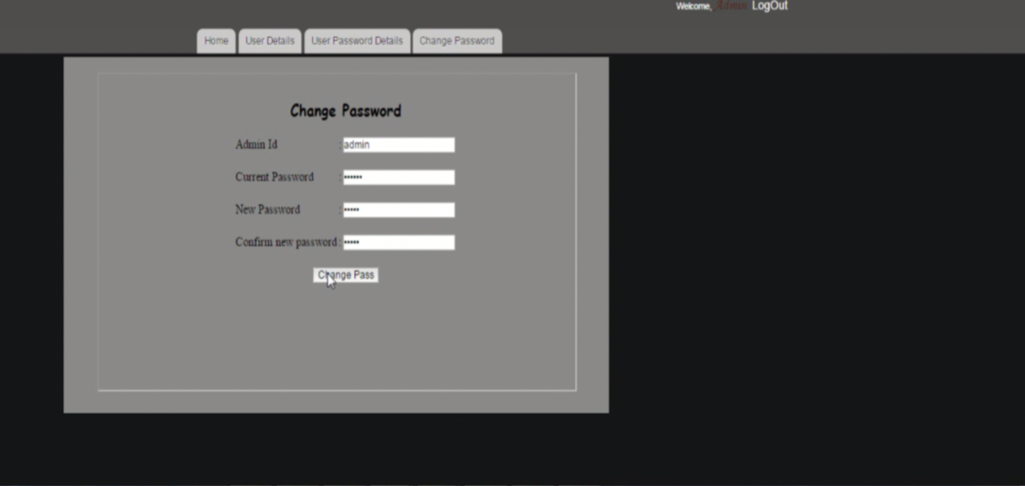

Android Application Screenshots

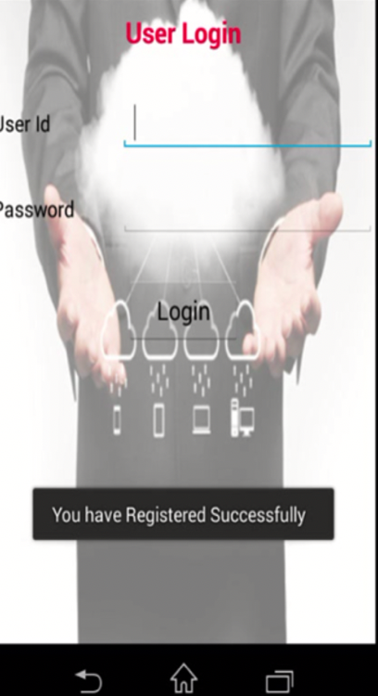Login Page

Registration Page

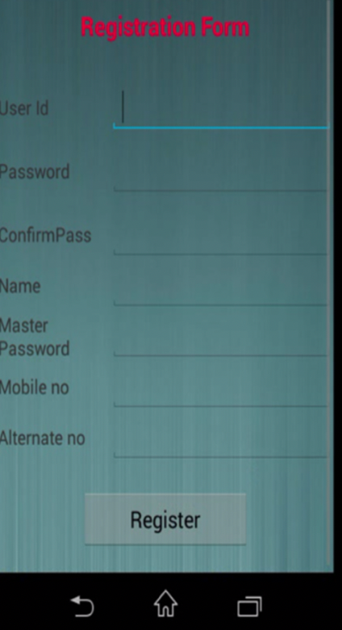

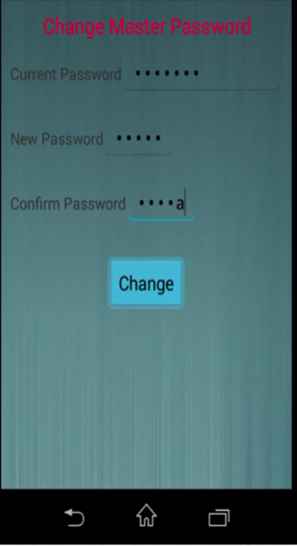Setting Master Password

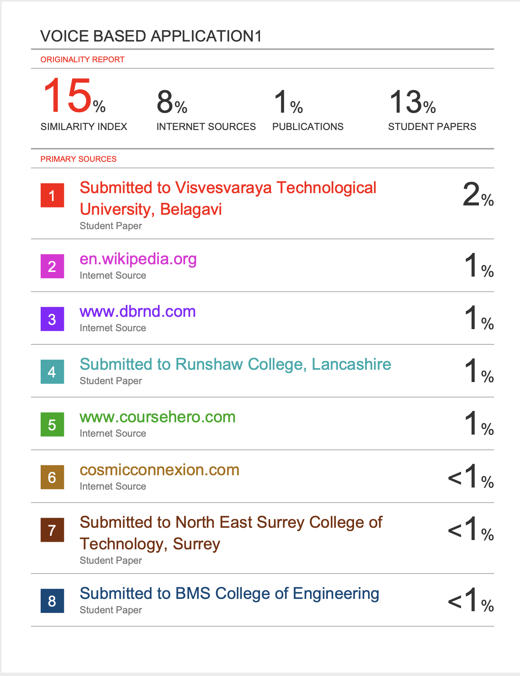APPENDIX B: Plagiarism Report

APPENDIX C: Details of publications

Author Names: PRADEEP SADANAND, KRITHIKA.G.M, DEEPTHI.R, ZAINA AHAD, HARINI.B.M

Paper Title: Voice Based Application for visually impaired

Name of the Conference or Journal: International Journal Of Innovative Research In Science, Engineering and Research.

Volume 9, Issue 4, April 2020.

**APPENDIX F: Programme Outcomes and Programme Specific Outcomes Mapped**

**PROGRAM OUTCOMES (PO)**

Undergraduate Programme, Deaprtment of CSE, BMSCE

|  |  |
| --- | --- |
| **PO1** | Engineering knowledge: Apply the knowledge of mathematics, science, engineering fundamentals, and an engineering specialization to the solution of complex engineering problems. |
|
| **PO2** | Problem analysis: Identify, formulate, review research literature, and analyze complex engineering problems reaching substantiated conclusions using first principles of mathematics, natural sciences, and engineering sciences. |
| **PO3** | Design/development of solutions: Design solutions for complex engineering problems and design system components or processes that meet the specified needs with appropriate consideration for the public health and safety, and the cultural, societal, and environmental considerations. |
| **PO4** | Conduct investigations of complex problems: Use research-based knowledge and research methods including design of experiments, analysis and interpretation of data, and synthesis of the information to provide valid conclusions. |
| **PO5** | Modern tool usage: Create, select, and apply appropriate techniques, resources, and modern engineering and IT tools including prediction and modeling to complex engineering activities with an understanding of the limitations. |
| **PO6** | The engineer and society: Apply reasoning informed by the contextual knowledge to assess societal, health, safety, legal and cultural issues and the consequent responsibilities relevant to the professional engineering practice. |
| **PO7** | Environment and sustainability: Understand the impact of the professional engineering solutions in societal and environmental contexts, and demonstrate the knowledge of, and need for sustainable development. |
| **PO8** | Ethics: Apply ethical principles and commit to professional ethics and responsibilities and norms of the engineering practice. |
| **PO9** | Individual and team work: Function effectively as an individual, and as a member or leader in diverse teams, and in multidisciplinary settings. |
| **PO10** | Communication: Communicate effectively on complex engineering activities with the engineering community and with society at large, such as, being able to comprehend and write effective reports and design documentation, make effective presentations, and give and receive clear instructions. |
| **PO11** | Project management and finance: Demonstrate knowledge and understanding of the engineering and management principles and apply these to one’s own work, as a member and leader in a team, to manage projects and in multidisciplinary environments. |
| **PO12** | Life-long learning: Recognize the need for, and have the preparation and ability to engage in independent and life-long learning in the broadest context of technological change. |

**Programme Specific Outcomes(PSO)**

Undergraduate Programme, Deaprtment of CSE, BMSCE

|  |  |
| --- | --- |
| **PSO1** | Apply Software Engineering Principles and Practices to provide software solutions |
| **PSO2** | Design and Develop Network, Mobile and Web based Computational systems under realistic constraints |
| **PSO3** | Design efficient algorithms and develop effective code. |

**B.M.S. College of Engineering.**

**Department of Computer Science and Engineering.**

**Attainment of POs and PSOs**

Batch no. : B12 Date: 01-07-2020

Project Title: Voice Based Application For Visually Impaired

**PROGRAM OUTCOMES**

|  |  |  |
| --- | --- | --- |
| **PO** | **Level (3/2/1)**  **3-High**  **2-Medium**  **1-Low** | **Justification if addressed** |
| **PO1** |  | Engineering knowledge: Apply the knowledge of mathematics, science, engineering fundamentals, and an engineering specialization to the solution of complex engineering problems. |
| **PO2** |  | Problem analysis: Identify, formulate, review research literature, and analyze complex engineering problems reaching substantiated conclusions using first principles of mathematics, natural sciences, and engineering sciences. |
| **PO3** |  | Design/development of solutions: Design solutions for complex engineering problems and design system components or processes that meet the specified needs with appropriate consideration for the public health and safety, and the cultural, societal, and environmental considerations. |
| **PO4** |  | Conduct investigations of complex problems: Use research-based knowledge and research methods including design of experiments, analysis and interpretation of data, and synthesis of the information to provide valid conclusions. |
| **PO5** |  | Modern tool usage: Create, select, and apply appropriate techniques, resources, and modern engineering and IT tools including prediction and modeling to complex engineering activities with an understanding of the limitations. |
| **PO6** |  | The engineer and society: Apply reasoning informed by the contextual knowledge to assess societal, health, safety, legal and cultural issues and the consequent responsibilities relevant to the professional engineering practice. |

|  |  |  |
| --- | --- | --- |
| **PO7** |  | Environment and sustainability: Understand the impact of the professional engineering solutions in societal and environmental contexts, and demonstrate the knowledge of, and need for sustainable development. |
| **PO8** |  | Ethics: Apply ethical principles and commit to professional ethics and responsibilities and norms of the engineering practice. |
| **PO9** |  | Individual and team work: Function effectively as an individual, and as a member or leader in diverse teams, and in multidisciplinary settings. |
| **PO10** |  | Communication: Communicate effectively on complex engineering activities with the engineering community and with society at large, such as, being able to comprehend and write effective reports and design documentation, make effective presentations, and give and receive clear instructions. |
| **PO11** |  | Project management and finance: Demonstrate knowledge and understanding of the engineering and management principles and apply these to one’s own work, as a member and leader in a team, to manage projects and in multidisciplinary environments. |
| **PO12** |  | Life-long learning: Recognize the need for, and have the preparation and ability to engage in independent and life-long learning in the broadest context of technological change. |

**PROGRAM SPECIFIC OUTCOMES**

|  |  |  |
| --- | --- | --- |
| **PSO** | **Level (3/2/1)**  **3-High**  **2-Medium**  **1-Low** | **Justification if addressed** |
| **PSO1** |  | Apply Software Engineering Principles and Practices to provide software solutions |
| **PSO2** |  | Design and Develop Network, Mobile and Web based Computational systems under realistic constraints |
| **PSO3** |  | Design efficient algorithms and develop effective code. |